**Project Design Phase**

**Problem – Solution Fit Template**

|  |  |
| --- | --- |
| Date | 15 February 2025 |
| Team ID | LTVIP2025TMID32163 |
| Project Name | Smart SDLC – AI Enhanced Software Development Lifecycle |
| Maximum Marks | 2 Marks |

### ****Problem – Solution Fit: Smart SDLC****

The **Problem–Solution Fit** is the validation that the issue faced by your target users (developers, learners, educators, or team leads) is real and frequent — and that your solution, Smart SDLC, directly addresses it in a meaningful, adoptable way.

### ****Purpose of this Fit for Smart SDLC****

✅ Solve **complex software development challenges** by matching your solution with the actual behavior and needs of developers.  
✅ Increase **adoption** by meeting users where they already are — in development environments where SDLC often gets neglected.  
✅ Sharpen your **product positioning and messaging** by focusing on pain points that matter most in everyday coding, planning, and testing workflows.  
✅ Build **trust** by solving frequent frustrations — such as lack of clarity, repetitive manual tasks, and misaligned SDLC practices.  
✅ Help users move from theory to action by understanding their **existing knowledge gaps** and tooling limitations.

**Template:**

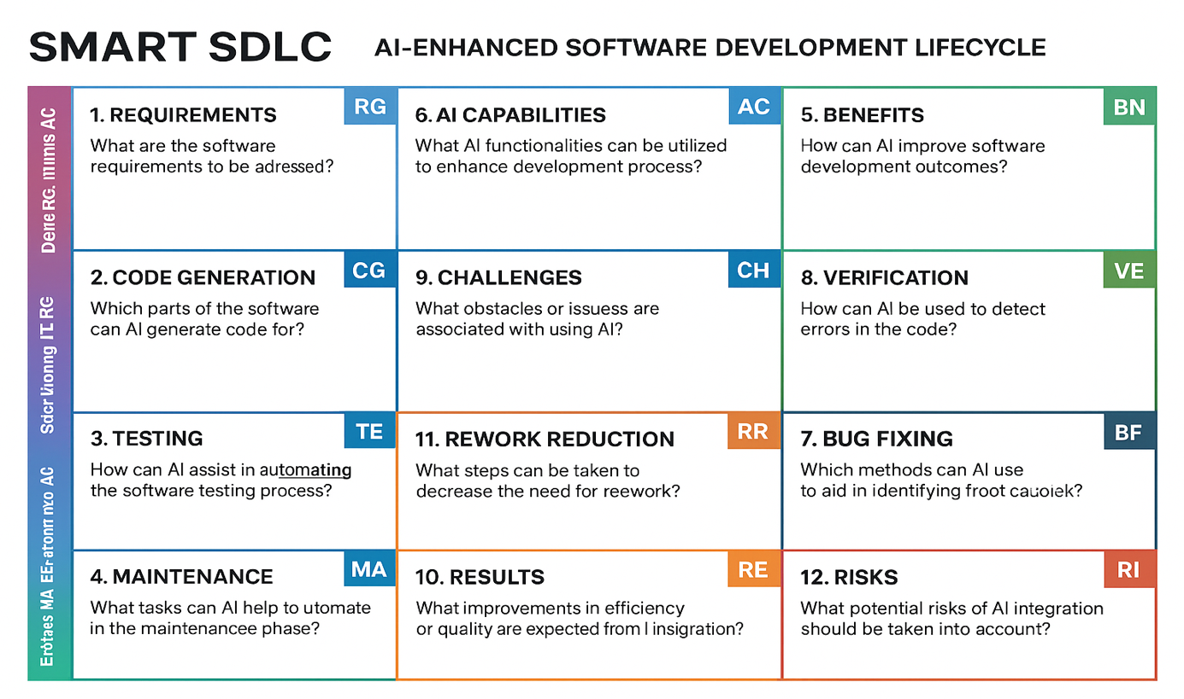

References:

1. <https://www.ideahackers.network/problem-solution-fit-canvas/>
2. <https://medium.com/@epicantus/problem-solution-fit-canvas-aa3dd59cb4fe>